HOME LOAN STATE BANK

Home Loan State Bank Annual Disclosure Statement

In connection with our efforts to keep you, our customers and the general public informed, and in accordance with the Federal Deposit Insurance Corporation Rules and Regulations Pmi 350- Disclosure of Financial and Other Information by FDIC-Insured State Nonmember Banks, we have prepared and now present our a disclosure statement¹ for the years end December 31, 2016 and
2015. This disclosure statement consists of our call report Income Statement (schedule RI), Changes in Equity Capital (schedule RI-A), Changes in Allowance for Loan and Lease Losses (schedule RI-B, part II), Balance Sheet (schedule RC), and Past Due and Nonaccrual, Loans, Leases, and Other Assets (schedule RC-N).

The aforementioned statements included in this financial disclosure are, to the best of my knowledge, correct and complete.

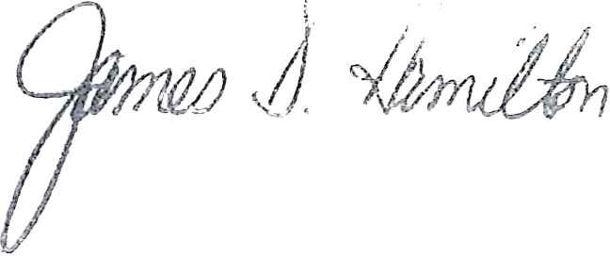Please direct any questions regarding the financial disclosures to Craig Springer at 205 N. 4th Street, Grand Junction, Colorado 81501 or call Mr. Springer at (970)243-6600.

James D. Hamilton
Chairman/CEO

¹The information in the disclosure statement has not been reviewed, or confirmed for accuracy or relevance, by the Federal
Deposit Insurance Corporation.

FDIC
James D. Hamilton, CEO • Craig N. Springer, President • Dennis King, Vice President
205 N. 4th Street • P.O. Box 100 • Grand Junction, CO 81502 • www.hlsb.com
(970) 243-6600 • FAX: (970) 254-0873

LENDER

