2016-2017

What are HSA’s? Why have an HSA?
Is an HSA right for you? How do HSA’s work? Saving with an HSA
Three different case studies

Qualified Medical Expenses

www.HLSB.com

HSA GUIDE

PRESENTED BY

HOME LOAN STATE BANK

205 N. 4th Street- Grand Junction, CO 81501 | (970) 243-6600
340 S. Townsend Ave- Montrose, CO 81401 | (970) 497-4280

When you’re choosing a health plan, there are many factors that affect your decision. If you want an option with flexibility, a high level of choice and tax-advantaged savings, a high deductible health plan with a health savings account (HSA) might be the right choice for you.

What Are HSAs?
Health savings accounts (HSAs) are a great way to save money and efficiently pay for medical expenses. HSAs are tax-advantaged
savings accounts that accompany high deductible health plans (HDHPs).

HSAs were created in 2003 to provide individuals who have HDHPs with a tax-preferred method of saving money for medical expenses. There are certain advantages to putting money into these accounts, including investment earnings and favorable tax treatment. The rationale behind the HSA/HDHP combination is that people will have a clearer idea of their medical costs and more control over their spending, enabling them to reduce their medical costs.

HSA money can be used tax-free when paying for qualified medical expenses, helping you pay your HDHP’s larger deductible.
At the end of the year, you keep any unspent money in your HSA. This rolled over money can grow with tax-deferred investment earnings, and, if it is used to pay for qualified medical expenses, then the money will continue to be tax-free. Your HSA and the money in it belongs to you—not your employer or insurance company.

An HSA can be a tremendous asset as you save for and pay medical bills because it gives you tax advantages, more control over your own spending and the ability to save for future expenses.

Why Have an HSA?
HSA/HDHPs take a different approach to health coverage than other plans with lower deductibles. Having an HSA provides you
with many benefits, including flexibility and easy saving, helping you plan and pay for medical expenses. HSA Advantages

Here are some of the advantages an HSA provides you with:

Security – Your HSA can provide a savings buffer for unexpected or high medical bills.

Affordability – In most cases, you can lower your monthly health insurance premiums when you switch to health insurance cover- age with a higher deductible, and these HDHPs can be paired with an HSA.

Flexibility – You can use your HSA to pay for current medical expenses, including your deductible and expenses that your insur- ance may not cover, or you can save your funds for future medical expenses, such as:
•Health insurance or medical expenses if unemployed
•Medical expenses after retirement (before Medicare)
•Out-of-pocket expenses when covered by Medicare
•Long-term care expenses and insurance

Also, you do not have to use your HSA to pay for medical expenses. You can withdraw money from your HSA at any time and for
any reason. However, if your HSA money is not used for medical expenses, you will have to pay income tax on your withdrawal. You will also have to pay a 20 percent additional tax, unless the withdrawal is made after you attain age 65, become disabled or after your death.

Savings – You can save the money in your HSA for future medical expenses, all while your account grows through tax-deferred investment earnings.

Tax Savings – An HSA provides you with triple tax savings:

1. Tax deductions when you contribute to your account

2. Tax-free earnings through investment

3. Tax-free withdrawals for qualified medical expenses

Control – You make the decisions regarding:

• How much money you will put in the account

• When to make contributions to the account

• Whether to save the account for future expenses or pay current medical expenses

• Which expenses to pay for from the account

• How to invest the money in the account

Portability – Accounts are completely portable, meaning you can keep your HSA even if you:

• Change jobs

• Change your medical coverage

• Become unemployed

• Move to another state

Ownership – Funds remain in the account from year to year, just like an IRA. There are no “use it or lose it” rules for HSAs, making it a great way to save money for future medical expenses.

Is an HSA Right for You?

HSAs are a growing trend in health care and offer many advantages, but whether it’s the right choice for you depends on several factors.

Comparing HSA/HDHPs to traditional health plans can be difficult, as each has pros and cons. For example, traditional health plans typically have higher monthly premiums, a smaller deductible and fixed copays. You pay less out-of-pocket costs due to the lower deductible, but you will pay more each month in premiums.

HDHPs with HSAs generally have lower monthly premiums and a higher deductible. You may pay more out-of-pocket medical ex- penses, but you can use your HSA to cover those costs, and you pay less each month for your premium.

The decision is different for each individual. If you are generally healthy and/or have a reasonable idea of your annual health care expenses, then you could save a lot of money from the lower premiums and valuable tax-advantaged account with an HSA/HDHP plan. For example, even someone with a chronic condition could take advantage of an HSA/HDHP plan if he or she has a good idea of his or her annual expenses and then budgets enough money to cover cost of care.

However, if you are older, more prone to illness or unexpected medical conditions, or prefer certainty in medical costs over the possible risk of unexpected out-of-pocket expenses, you may want to stick with a traditional plan. You’ll pay more in monthly pre- miums, but you will have a lower deductible and fixed copays.

To help determine if an HSA is right for you and how much you might save in taxes, contact Home Loan State Bank.

How Do HSAs Work?

To have an HSA and make contributions to the account, you must meet several basic qualifications. Here’s what you need to know to start saving with an HSA.

HSA Eligibility – In order to qualify for an HSA, you must be an adult who meets the following qualifications:

• Have coverage under an HSA-qualified, high deductible health plan (HDHP)

• Have no other health insurance plan (this exclusion does not apply to certain other types of insurance, such as dental, vision, disability or long-term care coverage)
• Are not enrolled in Medicare

• Cannot be claimed as a dependent on someone else’s tax return

HSAs must be used with an HDHP. To qualify as an HDHP, a health plan must satisfy requirements for the minimum annual deduct- ible and the maximum out-of-pocket expenses.

In 2016, the minimum annual deductible for a qualifying HDHP is $1,300 for an individual and $2,600 for a family. For 2017, the
HDHP minimum deductible will be $1,300 for an individual and $2,600 for a family.

Minimum Annual Deductible for a Qualifying HDHP

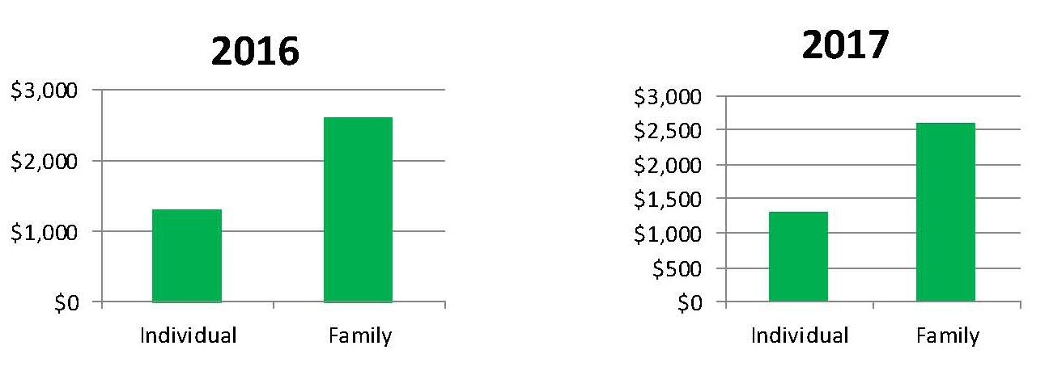

In addition, annual out-of-pocket expenses under the plan (including deductibles, copays and coinsurance) cannot exceed $6,550 in 2016 and 2017 for single coverage, and $13,100 in 2016 and 2017 for family coverage.

Annual Out-of-pocket Expenses Maximum

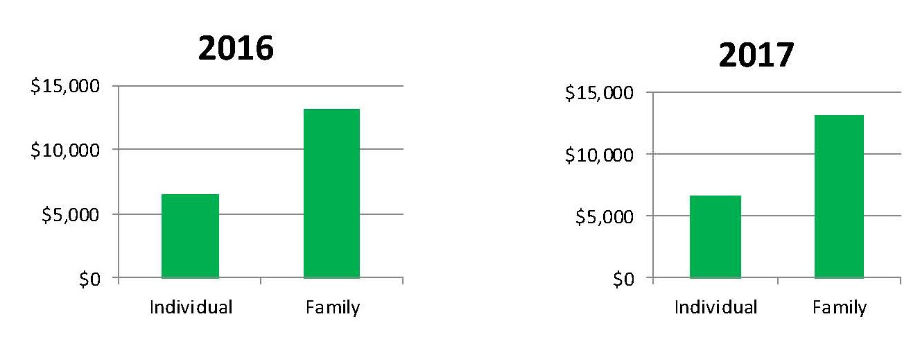

In general, the deductible must apply to all medical expenses (including prescriptions) covered by the plan. However, plans can pay for preventive care services on a first-dollar basis (that is, without a deductible or copay). Preventive care can include care such as routine prenatal and well-child care, child and adult immunizations, annual physicals and mammograms.

Opening Your HSA - Your employer may offer an HSA option, or you can open an account on your own through a bank or other finan- cial institution. Banks, credit unions, insurance companies and other financial institutions are all permitted to be trustees or custodi- ans of these accounts. Other financial institutions that handle IRAs or Archer MSAs are also automatically qualified to establish HSAs.

Contributions - Contributions to your HSA can be deducted when you file your income taxes. If your employer offers a Section 125 plan (sometimes called a “cafeteria plan”), you may be able to make your HSA contributions on a pre-tax basis. That means that your HSA contribution will be taken out of your wages and no federal income tax or employment tax will be withheld on the contribution.

Determining your contribution - Your eligibility to contribute to an HSA is determined monthly. You must have HDHP coverage on the first day of the month to make an HSA contribution for that month. There is a limited exception that allows individuals who be- come HSA-eligible during a calendar year to make the full contribution amount for that year. Under this exception, individuals who are eligible to contribute to an HSA on Dec. 1 of a calendar year are allowed to contribute an amount equal to the annual HSA con- tribution amount provided they remained covered by the HSA for at least the 12-month period following that year. Contributions can be made as late as April 15 of the following year.

Limits - You can make a contribution to your HSA for each month that you are eligible. For each month that you are eligible, you can contribute one-twelfth of the annual maximum for HSA contributions. The full contribution rule described above for individuals who are eligible on Dec. 1 of a calendar year is an exception to the rule that HSA contributions limits are determined monthly. You can contribute no more than the designated annual maximum. For 2016, the maximum is $3,350 for single coverage and $6,750 for family coverage. For 2017, the maximum is $3,400 for single coverage and $6,750 for family coverage. Individuals who are age 55 and older can also make additional “catch-up” contributions of up to $1,000 annually.

Annual Contribution Maximum

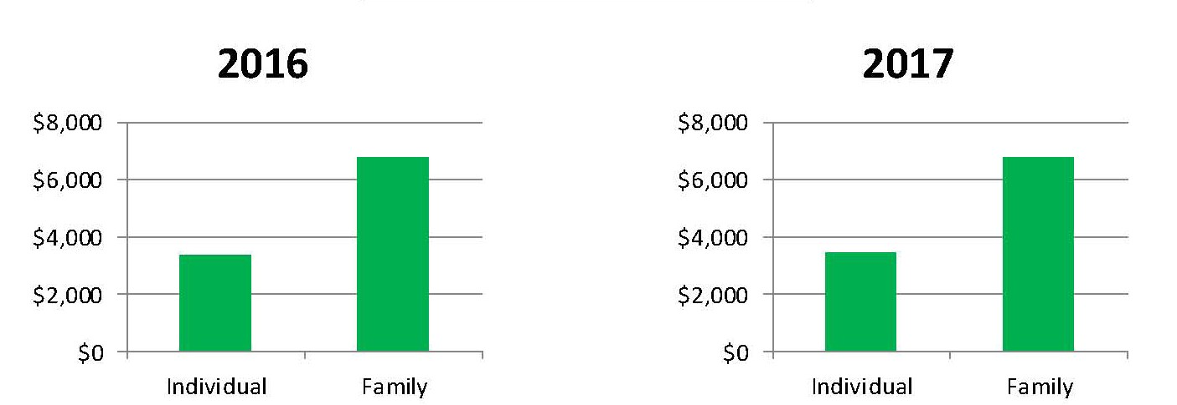

Who can contribute - Contributions to your HSA can be made by anyone, including you, your employer or a family member; the combined contributions of you and your employer (and anyone else making contributions to your HSA) can not exceed the HSA maximum contribution limit.

Contributions to the account must stop once you are enrolled in Medicare. However, you can still use your HSA funds to pay for medical expenses tax-free.

Using Your HSA
An HSA is managed by the account holder, giving you the choice of when to use your HSA dollars. You can begin using your HSA money as soon as your account is activated and contributions have been made. You can use your HSA account for any purpose, including paying expenses that are not qualified medical expenses. However, you only get the tax benefits of an HSA when you use the account for qualified medical expenses. If you use it for another purpose, you will be required to pay income tax on the withdrawal, and you may also be required to pay another 20 percent tax, unless you make the withdrawal after you reach age 65, become disabled or after your death.

Qualified Medical Expenses
You can use money in your HSA to pay for any qualified medical expense permitted under federal tax law, which includes most med- ical care and services, as well as dental and vision care. HSA distributions are tax-free if they are used for qualified medical expenses incurred by the account holder or his or her spouse or dependents. The qualified medical expenses must be incurred after the HSA is established.

Qualified medical expenses are defined in Section 213(d) of the federal tax code. Section 213(d) defines “medical care” to include amounts paid “for the diagnosis, cure, mitigation, treatment or prevention of disease, or for the purpose of affecting any structure or function of the body.”

You can use your HSA account to pay for your health plan deductible, your copay or coinsurance for doctor’s office visits and pre- scription drugs, your share of the cost for dental care, such as exams and cleanings, and your costs for vision care, such as exams, eyeglasses and contact lenses. See the back cover for a list of Qualified Medical Expenses.

Generally, you cannot use your HSA to pay for medical insurance premiums, except specific instances, including:

• Any health plan coverage while receiving federal or state unemployment benefits

• Continuation coverage under federal law (COBRA or USERRA coverage)

• Qualified long-term care insurance

• Any deductible health insurance for HSA account holders who are age 65 or over (whether or not they are entitled to

Medicare) other than a Medicare supplemental policy

You can use your HSA to pay for medical expenses for yourself, your spouse or your dependent children, even if your dependents are not covered by your HDHP. Any amounts used for purposes other than to pay for qualified medical expenses are taxable as income and subject to an additional 20 percent penalty. Examples of taxable expenses include:

• Medical procedures and expenses not considered qualified under federal tax law

• Over-the-counter drugs and medications without a prescription (except insulin)

• Other types of health insurance unless specifically described above

• Medicare supplement insurance premiums

• Non health-related expenses

After the age of 65, you can withdraw money for nonmedical expenses without penalty, but you will have to pay taxes on the money. If you become disabled, the account can be used for other purposes without paying the additional penalty. If you withdraw money from an HSA for nonmedical expenses before you turn 65 (or become disabled), you will have to both pay taxes and a 20 percent penalty.

Life Events
Various life events may affect your HSA.

New health plan (non-HDHP) – An HSA is an individually owned account. If you are no longer participating in an HDHP, you cannot make contributions to your HSA, but you can continue to use the money you have already saved in your HSA. If you are switching to a Marketplace plan under the Affordable Care Act (ACA), some plans, typically bronze and silver plans, may be HSA-compatible, in which case you can then choose to keep contributing to an HSA.

Employment status changes – An HSA is an individually owned account; if you leave your current employer, the HSA money is yours and you may choose to leave your funds in the current HSA account, transfer the funds to an HSA with your new employer or take a distribution and roll over the funds to another qualifying account within 60 days.

Divorce – The HSA owned by one spouse may be divided or transferred entirely to an HSA for the other spouse by court judgment in a divorce. If you transfer your HSA to your spouse as part of your divorce or separation, it is not a taxable transfer.

Death – You can designate a beneficiary to inherit your HSA after your death. The tax treatment of the HSA will then depend on whether a spouse or non-spouse inherited the HSA account.

Saving With an HSA

HSAs serve as a tax-advantaged fund that can be used to pay for current or future medical expenses. The account is consumer-con- trolled. If the funds are not used, the money will roll over to the next year and continue to grow over time. One of the most attractive features of the HSA is that these funds grow through the accrual of tax-free interest or investment earnings.

The HSA is proving itself to be a wise investment tool, not only for current health care needs, but also for long-term retirement plan- ning. The HSA fund is tax-deductible, compounds tax-free interest and earnings and is tax-free to withdraw from for medical bills. Also, people who are age 55 and older can make additional contributions, called “catch-up payments,” to their accounts in order to accelerate the rate of savings.

For example, if you spend $700 a year on health care costs, anything you contribute above that is money invested for your future. Maximum allowable contributions enhance this opportunity further, particularly for those investing at a younger age.

Because an HSA can be invested in the market with tax-free earnings, the opportunity for long-term growth is exponential. Owners of individual retirement accounts (IRAs) or Roth IRAs who are HSA-eligible can shift IRA funds to an HSA without facing a tax penalty. The IRS allows a one-time transfer that does not exceed your maximum annual HSA contribution limit. The same types of invest- ments permitted for IRAs are allowed for HSAs, including bank accounts, stocks, bonds, mutual funds, annuities and certificates of deposit.

You can build your HSA balance by consistently making contributions and investing what you roll over to the next year. If you start at a young age, you can amass considerable savings.

Your Potential Savings at Age 65

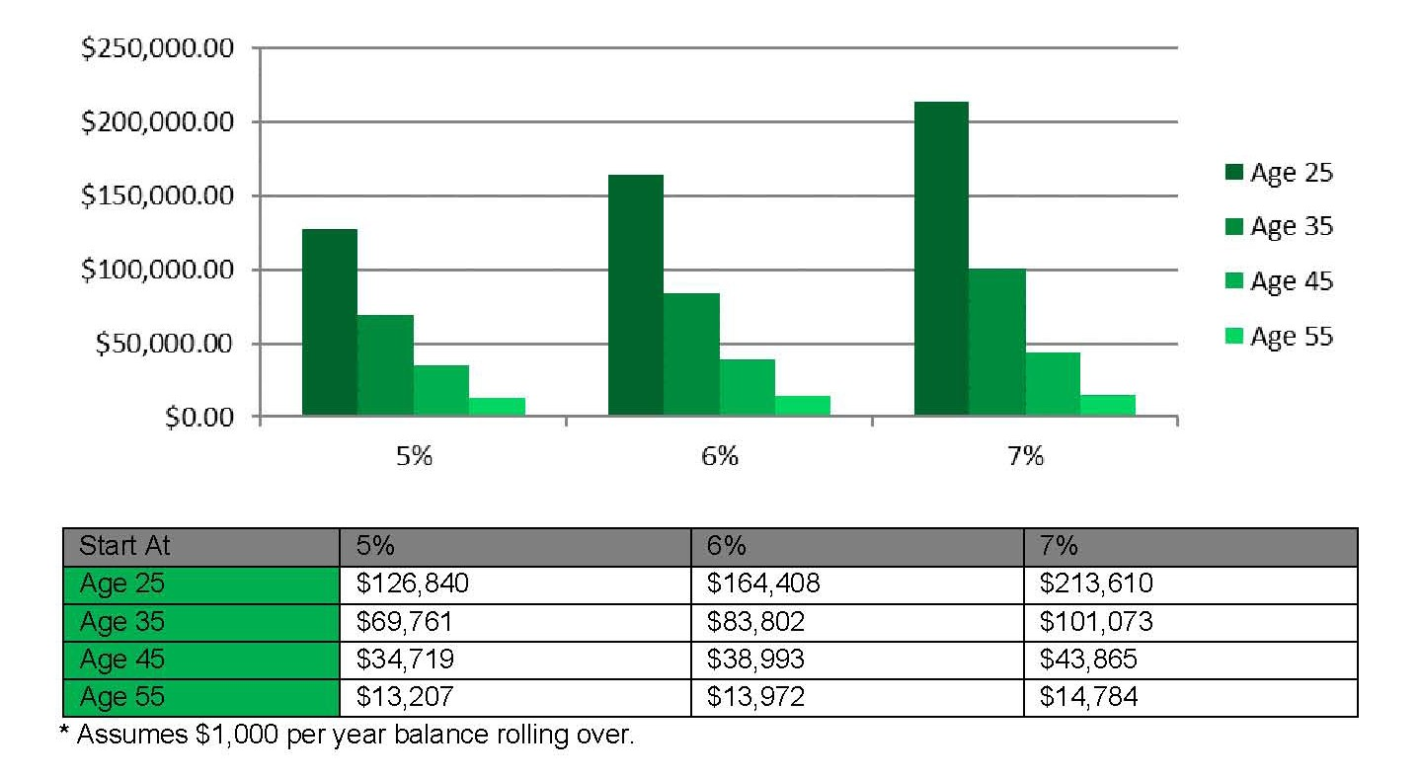

Case Studies and Examples

Following are three case studies that demonstrate how an HSA can benefit you in various life stages and circumstances.

HSA Case Study 1

Justin is a healthy 28-year-old single man who is active in sports and goes to the gym three times a week. He contributes $1,000 each year to his HSA. His plan’s annual deductible is $1,500 for individual coverage. If Justin uses his HSA to pay for covered services, this will reduce his out-of-pocket amount needed to meet his deductible before traditional health coverage begins. Here is a look at the first two years of Justin’s HSA plan, assum- ing the use of in-network providers. (This example only includes HSA contribution amounts and does not reflect any investment earnings.)

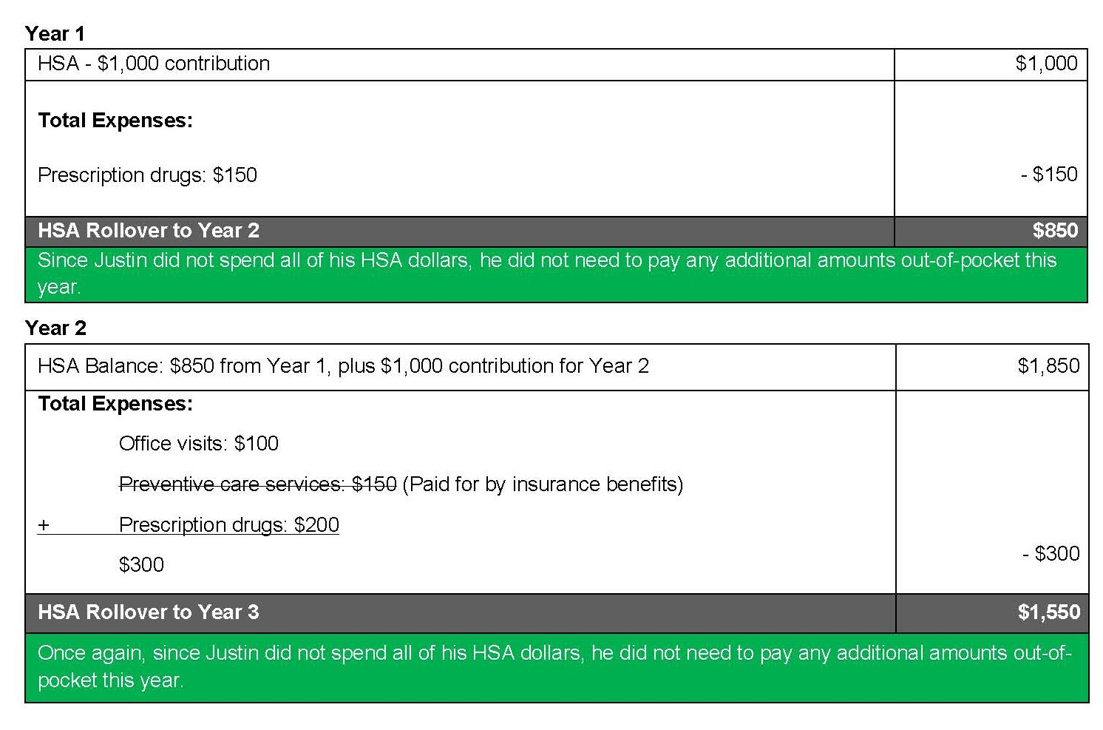

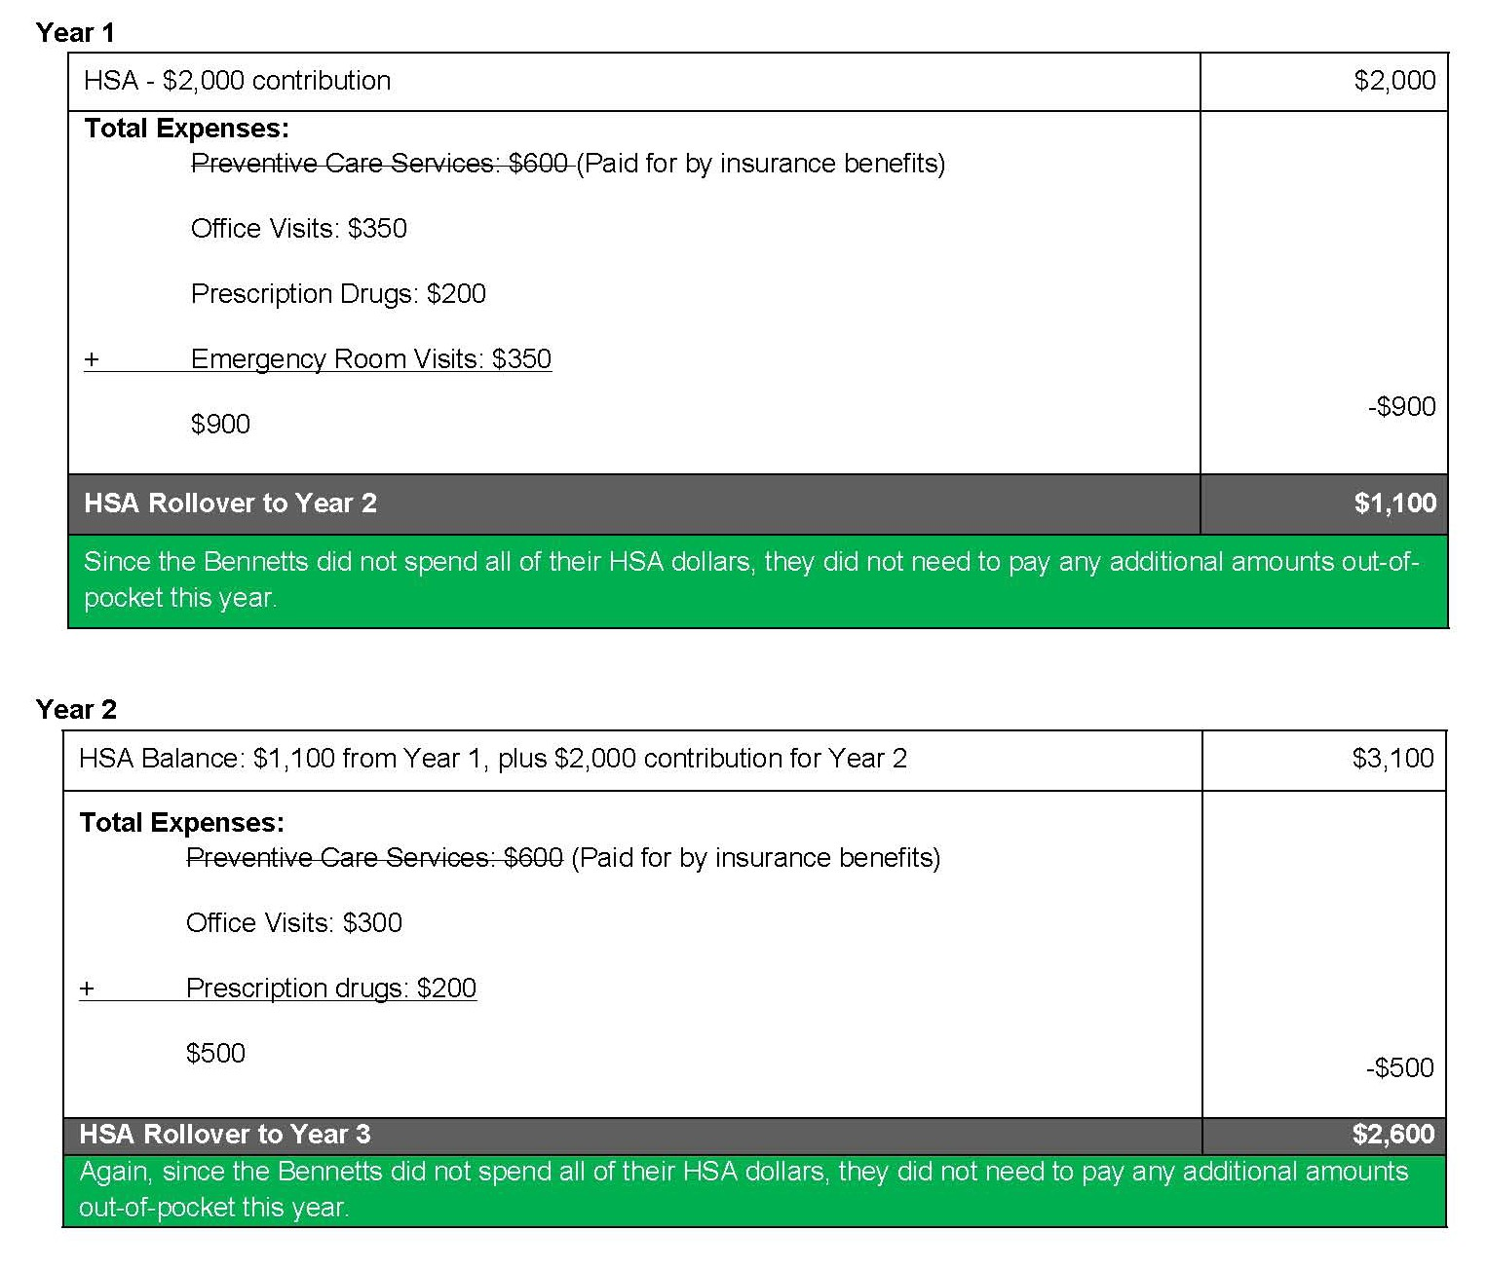
HSA Case Study 2

The Bennetts haven’t had the best luck when it comes to medical expenses—daughter Jasmine was diagnosed with asthma a few years ago, and son Alex has broken several bones. They contribute $2,000 to their HSA each year. Their plan’s annual deductible is $5,000 for family coverage. If they choose to use their HSA to pay for covered services, it will reduce the out-of-pocket amount needed to meet their deductible before traditional health coverage begins. Here is a look at the first two years of the Bennetts’ HSA plan, as- suming the use of in-network providers:

HSA Case Study 3

Angela is divorced and in good health at age 62, but, due to a car accident, her expenses were higher than usual her second year of enrollment. Thanks to her HSA savings from her first year, she had money to help cover most of her expenses in the second year. Angela contributes $2,000 to her HSA each year, and her plan’s deductible is $2,500. If she chooses to use her HSA to pay for covered services, this will reduce or eliminate the out-of-pocket amount needed to meet her deductible before traditional health coverage begins. Here is a look at the first two years of Angela’s HSA plan, assuming the use of in-network providers:

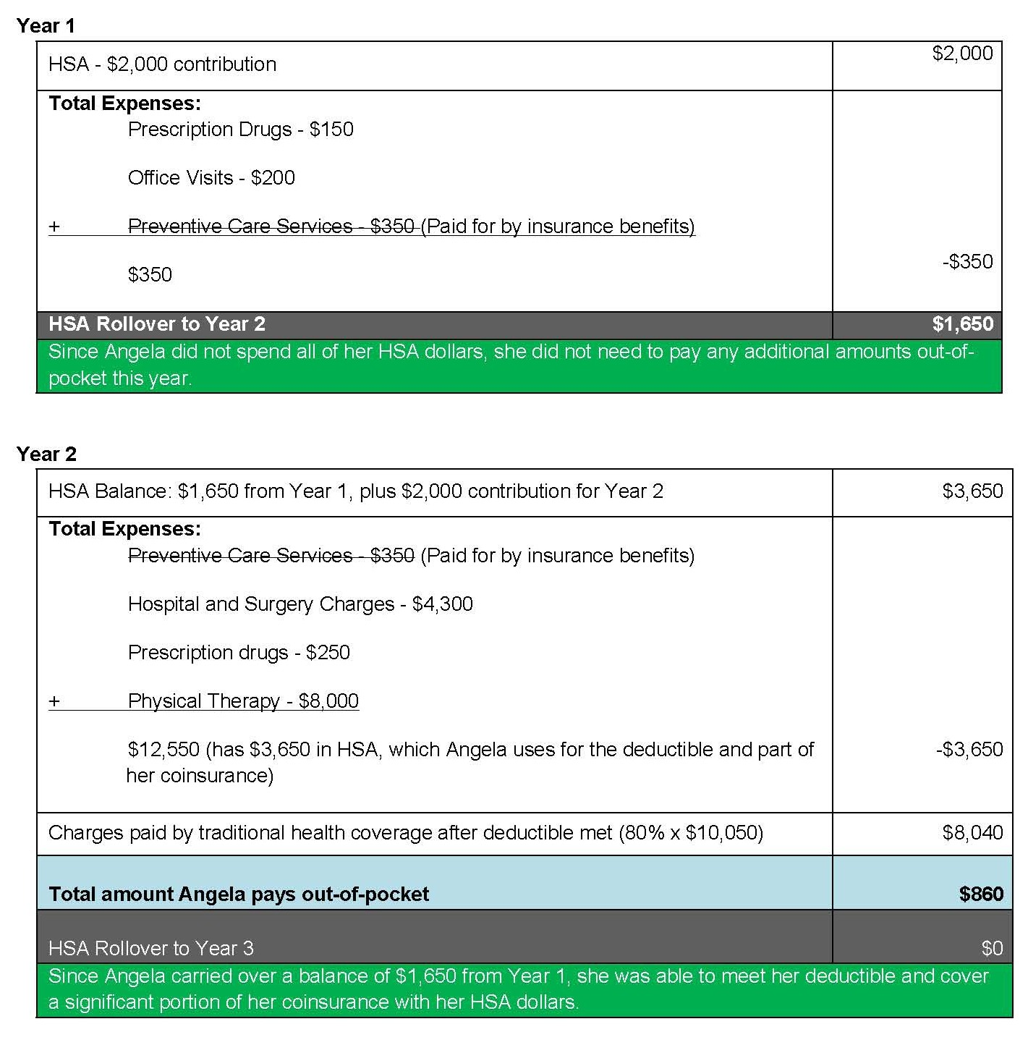

Qualified Medical Expenses
The qualified medical expenses that can be reimbursed by an HSA on a tax-free basis are limited to expenses for medical care (as defined in the federal tax code) for the HSA owner and his or her spouse and dependents, to the extent those ex- penses are not reimbursed by the high deductible health plan or any other source.

The federal tax code defines medical care expenses as amounts paid for the diag- nosis, cure, mitigation or treatment of a disease, and for treatments affecting any part or function of the body. The expenses must be primarily to alleviate a physical or mental defect or illness.

The products and services listed below are examples of medical expenses that may be eligible for payment under your HSA on a tax-free basis. This list is not exhaustive; additional expenses may qualify as medical expenses, and the items listed below are subject to change. Keep in mind that, under a rule that went into effect Jan. 1, 2011, over-the-counter medicine or drug expenses (other than insu- lin) cannot be reimbursed tax-free from your HSA without a prescription. This rule does not apply to items for medical care that are not medicines or drugs.
HSA Recordkeeping
If you have an HSA, you are ultimately responsible for proving how the account is used because it is individu- ally owned. Typically, your HSA provider will give you an HSA debit card (or checks) to pay directly from your HSA, or you can pay out-of-pocket and request reimburse- ment later. With an HSA, you must keep proper records for your expenses to avoid tax headaches later on.

Documentation is key - An HSA can be used for a wide range of health care services within the limits estab- lished by law. Be sure you understand what medical expenses are HSA-qualified, and be sure you are able to produce receipts for those items or services that you purchase with your HSA. You may face income taxes and a 20 percent penalty on any distribution that you cannot prove was for a qualified medical expense.

Your HSA statement - Your HSA provider will send you a statement outlining your contributions, employer

Acupuncture Alcoholism treatment Ambulance services
Annual physical examination
Artificial limb or prosthesis
Birth control pills (by prescription) Chiropractor
Childbirth/delivery
Convalescent home
(for medical treatment only) Crutches
Doctor’s fees
Dental treatments
(including x-rays, braces, dentures, fillings, oral surgery)
Dermatologist Diagnostic services Disabled dependent care Drug addiction therapy Fertility enhancement
(including in-vitro fertilization) Guide dog
(or other service animal) Gynecologist
Hearing aids and batteries
Hospital bills
Insurance premiums** Laboratory fees Lactation expenses
Lodging (away from home for outpatient care)
Nursing home
Nursing services Obstetrician Osteopath Oxygen Pregnancy test kit Podiatrist
Prescription drugs and medicines
(over-the-counter drugs are not IRS- qualified medical expenses unless prescribed by a doctor)
Prenatal care & postnatal treatments
Psychiatrist
Psychologist
Smoking cessation programs Special education tutoring Surgery
Telephone or TV equipment to assist the hearing or vision impaired
Therapy or counseling
Medical transportation expenses
Transplants Vaccines Vasectomy Vision care
(including eyeglasses, contact lenses, lasik surgery)
Weight loss programs
(for a specific disease diagnosed by a physician – such as obesity, hypertension, or heart disease)
Wheelchairs
X-rays
contributions made on your behalf, payments made to providers from your HSA, interest earned and any fees charged to your account. Keep these statements safely filed away as you would any other bank statement be- cause they may be required in the event of an IRS audit.

Maintaining records - To protect yourself in the event that you are audited by the IRS, keep records of all HSA documentation for at least as long as your income tax return is considered open (subject to an audit), or as long as you maintain the account, whichever is longer. Hold on to any insurer’s explanation of benefits state- ment that documents your expenses for services cov- ered under your HDHP. Also, when you pay an expense from your HSA and the expense is not filed with your health insurance carrier (for example, a vision or dental expense not covered by insurance), make sure you save the receipt.

Ask a Home Loan State Bank representative for a sample HSA log sheet.

HOME LOAN

*For purposes of reimbursement of qualified long-term care premiums from an HSA, reim- bursement in excess of the amount that may be deducted on an individual’s personal tax return is not an eligible expense. Section 213(d)(10) of the federal tax code establishes the tax deduction allowed for qualified long-term care premiums on individual tax returns. If the HSA reimburses long-term care premiums for an amount greater than what is set forth in Section 213(d)(10), the amount greater than what is allowed is included in the account holder’s taxable income and is subject to a 20 percent penalty.
STATE BANK

www.HLSB.com
205 N. 4th Street- Grand Junction, CO 81501 | (970) 243-6600
340 S. Townsend Ave- Montrose, CO 81401 | (970) 497-4280

